1. Write a program to read a text file and print the number of rows of data in the document.

Val A = sc.textFile("/home/acadgild/data.txt")

A.count

**Screen Shot:**

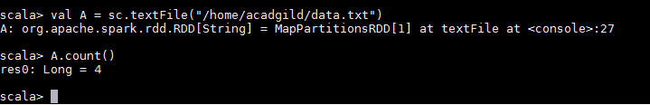

1. Write a program to read a text file and print the number of words in the document.

Val A = sc.textFile("/home/acadgild/data.txt")

val words = A. flatMap (word => word. split (" "))

counts.count();

**Screen Shot:**

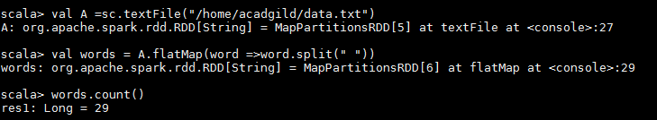

3. We have a document where the word separator is -, instead of space. Write a spark

code, to obtain the count of the total number of words present in the document.

Val A = sc.textFile("/home/acadgild/data.txt")

val words = A. flatMap (word => word. split ("-"))

counts.count();

**Screen Shot:**

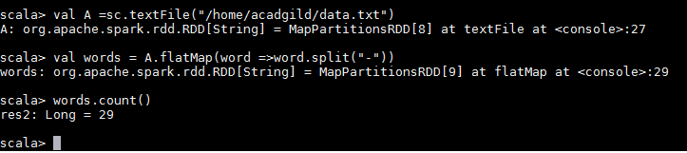

Sample document :

This-is-my-first-assignment.

It-will-count-the-number-of-lines-in-this-document.

The-total-number-of-lines-is-3